**Fault Detection Using Integrated Optical Time-Domain Reflectometer(OTDR) in Long Haul Fiber Transmission**

Kwadwo Danso Acheampong, Akyena Kwaku Sarfo and Dr Issac Adjaye Aboagye

School of Engineering Sciences, University of Ghana, Legon

**ABSTRACT**

Fiber optic communication has become one of the most important parts of modern communications due to the rapid development of various applications such as Internet of things, internet data and services, medicine and the military. They have excellent data conveying properties because of their enormous bandwidth and lower attenuation. Due to recent developments in communication technology, there is the need for massive amount of information to flow uninterruptedly, therefore, network outages have become unacceptable. However, optical fibers sometimes suffer faults to due to some external factors that are out of our control hence, disruptions are unavoidable at some point especially in long haul fiber transmission. Some of these faults include bends, broken fiber, connectors, splice effects, crack, and breakdowns along an optical fiber. This research reviews a novel technique for measuring transmission characteristics of optical fibers used in long haul transmission. We used the Integrated Optical Time Domain Reflectometer (OTDR) device to detect faults in a fiber link using different distances and events. It is a standard technique used to investigate the quality of optical fiber installations. Therefore, faults such as a splice, break, crack, connector and other attenuation along an optical fiber can be observed by studying the visual representation on the OTDRs’ screen. We also used the Optisystem software to detect faults in long haul transmission using different distances. The simulated results and the experimental results were compared with special emphasis on the precision of the fault location and other factors. The results obtained show that, the integrity of the signals was good and the location faults were achieved which is beneficial to help keep disruptions in the network signals to a minimum.

**Keywords**: Optical Time Domain Reflectometer, Fault detection, Rayleigh scattering, Events Fiber Optic Communication, Fresnel Reflections.

1. **Introduction**

The ability of fiber to transmit information over long distances is crucial to our daily lives especially in the areas of communication systems, electronics, medicine, military, and sensors [1]. Optical fiber has now become the backbone of many network systems due to its enormous bandwidth and low attenuation. The information-carrying capacity of optical fiber over long distances is greater, compared to coaxial cables, twisted pair, and other wireless communication links. In addition to that, optical fibers are light in weight and immune to the various disturbances such as electromagnetic waves and radio frequency interference. With recent advancement in technology, communication systems of today are rapidly developing to cope with new technologies. These new technologies seek to transfer data at high speed, over a reliable and secure systems over thousands of kilometres and as such, optical fiber is the cornerstone for these systems. Optical fiber is essential for the continuous growth of communication systems, and also, provide a platform for new generations which will be essential to the widespread use of Internet services. Even though optical fiber has now become the backbone of communication in our world today, these lines must be kept active as often as possible. Nevertheless, some external factors can cause disruptions in the fiber line are unavoidable at some point in time. In view of this situation, the OTDR is used to locate defects and problems in the optical fiber. OTDR testing is the best approach for finding the exact position of broken optical fibers in an installed optical fiber cable. An OTDR's basic components are a laser diode source and a photo detector. A high-intensity optical pulse is fired into an optical fiber, and the observed reflection is graphically displayed on the screen of the OTDR. Because it is a light-based technique, it basically measures how much of the light fired into a fiber is reflected back out after a certain amount of time. By looking at the visual representation on the OTDRs' screen, one can observe losses due to splice, break, crack, connector, and other attenuation along a fiber that can extend over long distances.

* 1. **Problem Definition**

Many sophisticated algorithms and designs have been invented to help the activities of telecommunication operators and fiber optic users to accomplish different purposes. Some of the operators do not have some these systems, designed purposely for the detection of long-haul fiber transmission but rather for shorter distances as well as using archaic ways to detect fault in long haul transmission. Some of the systems have become obsolete and cannot compete with the increasing challenges associated with them. When there is a flaw in fiber network transmission in a major telecom organization, a ton of organizations such as business firms, hospitals, military and others in Ghana get affected. For instance, smartphones which use the internet for some of the services on it and Telcos which are responsible for monetary transactions and other call services are disrupted because of a break in the optical fiber. The impact of the instances stated can cause extraordinary misfortune in people's business. Also, in the case way influence the health sector and numerous different sectors since passing on of enormous information is a necessity now.

* 1. **Project Objectives**

The objectives of this project are:

1. To develop a system, ensure that faults in fiber links are located quickly.
2. To develop a system to ensure minimal service disruption in the fiber link.
3. To have an idea of abnormalities in the optical cable over a long distance.
4. Using an OptiSystem simulation tool v.7 to build the system and then, compare the output results of our simulation with the result of the practical implementation.
5. Determine the best parameters in order to achieve the required results.
   1. **Relevance of Project**

The project seeks to provide the following benefits:

* To have overview abnormalities or faults in the optical cable.
* Measure some parameters of the cable under test over long distances.
* Ensure minimal service disruptions of the fiber link.
  1. **The Proposed Work**

Despite the numerous functionalities of the Optical Time Domain Reflectometer, we intended to include other parameters that OTDRs do not properly calculate such as cable loss and splice joint locations, and also aim to achieve better response times. This will help technicians quickly know how to attend to these faults and parameters that were affected by the damage caused to the cable as well as taking into consideration the best possible solution for restoration of the fiber link. This will help ensure minimal service disruption in the fiber link.

* 1. **Scope of Work**

Fault detection in fiber cables over long haul transmission covers both aerial and underground links. OTDRs characterize features such as attenuation uniformity and attenuation rate, segment length, location and insertion loss of connectors and splices, and other events such as sharp bends that may have been incurred during cable installation or afterward [10]. This project covers the measurement of cable loss and time taken to detect a fault in addition to the OTDRs’ other features.

1. **System Design and Development Process**

**System Architecture**

The figure below shows the entire system. The OTDR is the main component that is connected to the cable under test and serves as where major parameters can be viewed. The launch cables both near and far end is used to connect the OTDR to the fiber link under test and it depends on the distance of the fiber cable under test to improve accuracy and authenticity. They are also designed to measure the insertion loss of both the near and far end of the fiber cable.

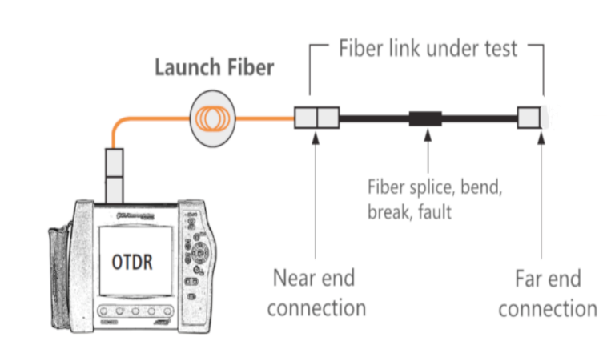

Figure 1 System architecture of the various interconnections

* 1. **Requirements, Analysis and Specifications**

The system's development would be impossible without clearly noting the requirements it must meet. This was completed and classified into two major groups: functional and non-functional. They are thoroughly discussed in the following section

**Functional Requirements**

The detection faults using the integrated OTDR is based on the following requirements:

1. The device will be at a point in the link.
2. The device will be able to determine the splitter channels.
3. Proper splicing will aid in achieving accurate results.
4. The device will be able to determine the trace(strength) in the cable.
5. The device will be able to return information within the specified time.

**Non-functional Requirements**

1. **Usability**: The user must be able to view and interpret the various parameters on a screen.
2. **Reliability**: Information shown on the OTDR will not be accurate if not calibrated properly.
3. **Performance**: Depending on the proper calibration of the device, required results are achieved.

**Data Sources**

For the scope of the project, we needed standard specifications in order to get accurate measurements. These standard measurements were from verified standard fiber optic association that is the Fiber Optic Association. They spell out the required measurements and specifications needed to do testing with an OTDR as well as standard cable measurements and accepted cable losses for the cables in order to achieve accurate results. We used the required specifications to model the system for our testing purposes at various lengths. These parameters are in accordance with TIA/EIA and other industry specifications

|  |  |
| --- | --- |
| FIBER TYPE | SINGLE MODE |
| Wavelength | 1550nm |
| Fiber attenuation per km | 0.3 dB  (These values are in accordance  of TIA/EIA and other industry  specifications  0.3dB |
| Connectors | 0.75dB |
| Splice loss | 0.01dB |
| Fiber length per drum | 1km |

Table 1 Specifications

* 1. **Design Process**

The implementation of the work consisted of a new fiber link, a launch cable and an OTDR machine. The new link was setup with splice joints and intentional breaks in the cable which was to help to achieve results. Ours was to setup the whole system and attain various results at different lengths. A fiber cable of about 6 kilometres was used. This cable was divided into various lengths that is 15 metres, 50 metres, 150 metres and 200 metres, 1 kilometre, 4 kilometres, and 6 kilometres. We then spliced these various lengths together in order to measure attenuation level at these various lengths in the cable as well as measurement of power. Next, the cable under test is spliced to an access terminal box, where the launch cable can be connected to in order for the OTDR to troubleshoot through the fiber link. After troubleshooting, results are acquired on the OTDR screen indicating the splice joints as well as losses that was also calculated by the OTDR. From there, we can deduce if these parameters are acceptable and meet the requirements that have been set.

**Project Flow Diagram**

To start fault detection using the OTDR, necessary parameters must be set for testing the cable. These parameters include frequency, pulse width and time. The mentioned parameters help in the detection of faults on a new link. After proper configuration of the device, troubleshooting then takes place that is, the OTDR sends light pulses into the fiber link for fault detection. Absorption and Rayleigh scattering cause certain losses in the transmitted pulse during the propagation of light pulses inside the fiber. Splices on the fiber, as well as bends within it, cause some losses. The light energy can sometimes be reflected due to variations in the refractive index. The backscattered light returns to the OTDR through the fiber and is directed to a photodetector via an optical circulator. The OTDR uses the reflected light pulses to make calculations and measurements. Also, signal strength is measured for specific intervals of time and is used to characterize events. Then a signal processing block that converts the signals into a proper form of display. The display shows a trace that is the various events on the optical fiber link represented as peaks and slight bends. From the trace, if there is a fault, the location of the fault is shown then, the fault is attended to and resolved. However, if there is no fault in the cable, then a trace is shown as well but from the trace, it will be seen that there are no faults on the optical fiber link and operations continue.

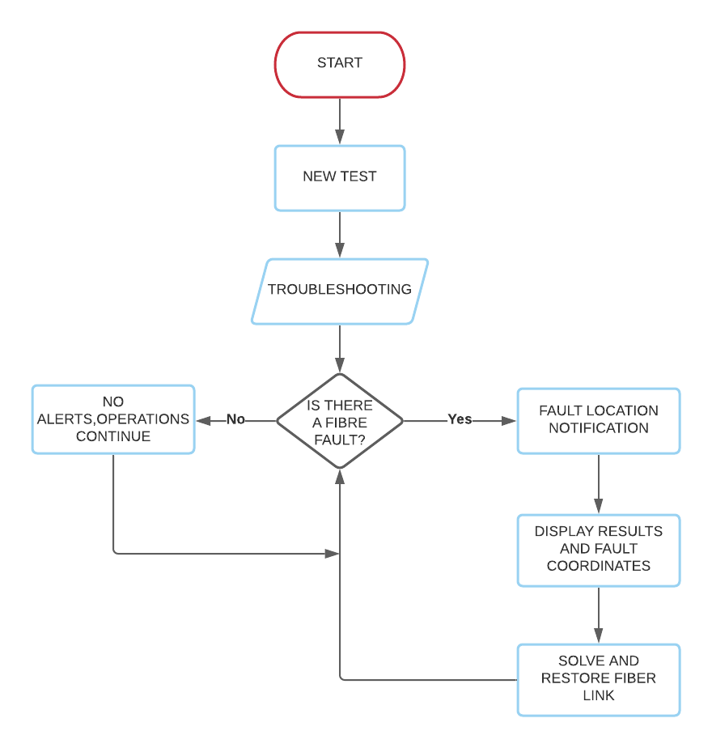

Figure 2 System flow diagram

* 1. **System Modelling and Simulation**

To model the desired system, we had to consider some parameters and make some calculations for the project.

**Link Budget**

Fiber optic link budget also known as “loss budget,” it indicates the total acceptable amount of optical loss {decibels (dB)} that a fiber link can have. These results from losses of events in an installed plant/system. This is denoted by

*Link budget = [ d (km) x dB/km] + [*α *x n] + [*β *x nc] + [s]*

Where d = fiber length

dB/km = fiber attenuation per kilometer

α = splice loss

n = number of splices

β = connector loss

nc = number of connectors

s = safety margin

Per this formula and parameters which are in accordance with TIA/EIA and other industry specifications below, we calculated for the total acceptable amount of optical loss {decibels (dB)} that a fiber link can have.

|  |  |
| --- | --- |
| Fiber type | Single Mode |
| Wavelength | 1550 nm |
| Fiber attenuation per km | 0.3 dB |
| Connector loss | 0.75 dB |
| Splice loss | 0.01 dB |
| Safety margin | 0.3 dB |

Table 2 TIA/EIA Specifications

**Simulation**

The simulation is focused on simulating the fault detection system. The components that were used are shown in the figure below. The components for the simulation process were taken from the component library. The specific parameters to ensure that accurate results are achieved is then inputted into the various components. The results are then monitored by meters connected to them. The figure below shows the various interconnections between the components.

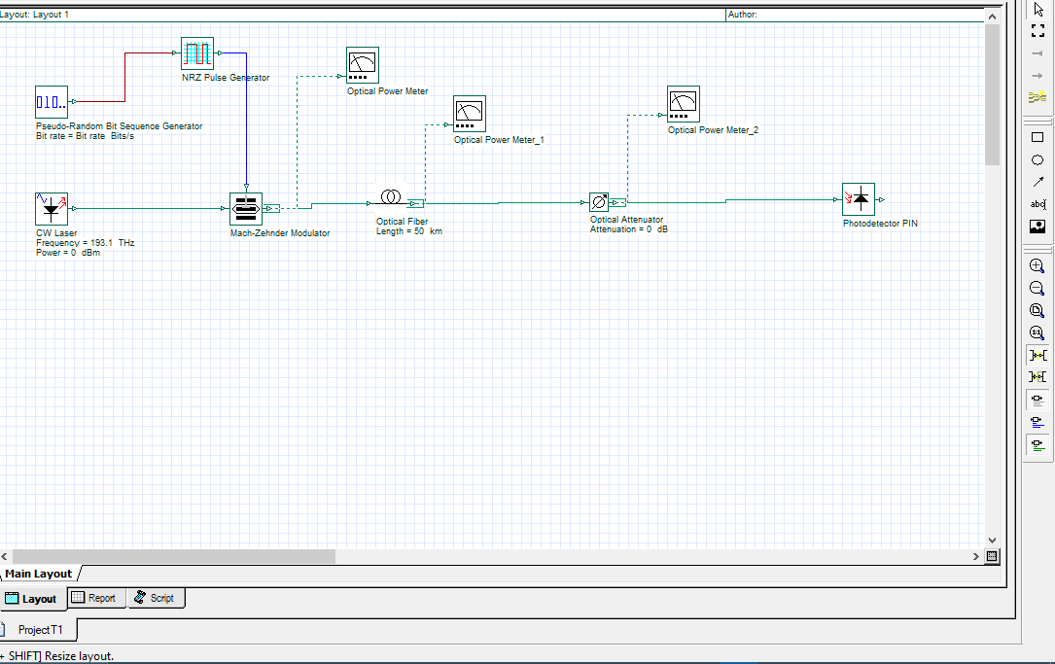

Figure 3 Interconnections of components in OptiSystem

|  |  |  |  |  |
| --- | --- | --- | --- | --- |
| **Items** | **Description** | **Quantity** | **Unit Price (cedis)** | **Total Price (cedis)** |
| 1 | 48 Core Fiber Optic Cable (All Dielectric Self Support) | 30 | 5 | 150.00 |
| 2 | 4 Port ODF | 2 | 300 | 600.00 |
| 3 | Fiber Distribution Box | 1 | 1,200 | 1,200.00 |
| 4 | Fiber Optic Cable Patch Cords (Duplex SC-LC/UPC/10m) | 1 | 150 | 150.00 |
| 5 | Fiber Optic Cable Patch Cords (Duplex SC/APC-SC/UPC/5m) | 2 | 80 | 160.00 |
| 6 | Fiber Optic Cable Patch Cords (Duplex SC-SC/UPC/3M | 1 | 50 | 50.00 |
| 7 | Small Form Factor Pluggable (SFP) | 2 | 800 | 1,600.00 |
| 8 | Splice Joint Closure | 1 | 400 | 400.00 |
| 9 | SC/UPC pigtails | 3 | 15 | 45.00 |
| 10 | Access Terminal Box (ATB) | 1 | 60 | 60.00 |
| 11 | 1:8 Optical Fiber Splitter Channel | 2 | 350 | 700.00 |
| 12 | **TOTAL** |  |  | 5,115.00 |
|  | **VAT 3%** |  |  | 153.45 |
|  | **GRAND TOTAL** |  |  | **5,268.45** |

*Table 3:**Cost Calculation*

1. **Implementation and Testing**
   1. **Simulation, Results and Discussions**

**Simulation with OptiSystem**

For the simulations, we tested the system’s attenuation using various parameters at various fiber lengths to achieve the best results. These parameters include, the wavelength and the pulse width. The wavelength under which the system was tested was set to 1550 nm. The pulse width was selected to be 10 ns and 50 ns to ensure better resolution of the OTDR and distance trade-offs on every trace. The direction (length) of the transmission was set from end to end (A to B). Different dynamic ranges were tested based on our OTDR design and settings. The trace analysis from the start to the end was projected onto a power meter where the analysis of the power before and after the signal was sent is accessed.

**Simulated Results**

For the simulated results, we tested different dynamic ranges with different attenuation values in order to monitor the optical power before and after a signal was sent. We tested for dynamic ranges of under a kilometer, a kilometer, 4 kilometers and 6 kilometers. We then came up with tables for the various losses that we tested for the distances. Graphs were plotted to help interpret the results, to see how distance affects attenuation. From the subsequent graphs, it can be seen that as the distance increases, attenuation also decreases. Also, when the losses on the fiber link are increased, the optical power also decreases per the amount of loss that the optical fiber had. The tables below show the various losses that we tested for the distances

|  |  |
| --- | --- |
| Distance (m) | Optical power (dB) |
| 400 | * 5.298 |
| 1000 | * 5.410 |
| 4000 | * 6.018 |
| 6000 | * 6.418 |

*Table 4 Optical power loss for 2 dB*

|  |  |
| --- | --- |
| Distance (m) | Optical power (dB) |
| 400 | * 7.298 |
| 1000 | * 7.410 |
| 4000 | * 8.018 |
| 6000 | * 8.418 |

*Table 5 Optical power loss for 4 dB*

|  |  |
| --- | --- |
| Distance (m) | Optical power (dB) |
| 400 | * 9.298 |
| 1000 | * 9.410 |
| 4000 | * 10.018 |
| 6000 | * 10.418 |

*Table 6 Optical power loss for 6 dB*

|  |  |
| --- | --- |
| Distance (m) | Optical power (dB) |
| 400 | * 11.298 |
| 1000 | * 11.410 |
| 4000 | * 12.018 |
| 6000 | * 12.418 |

*Table 7 Optical power loss for 8 dB*

**Result Analysis with Graph**

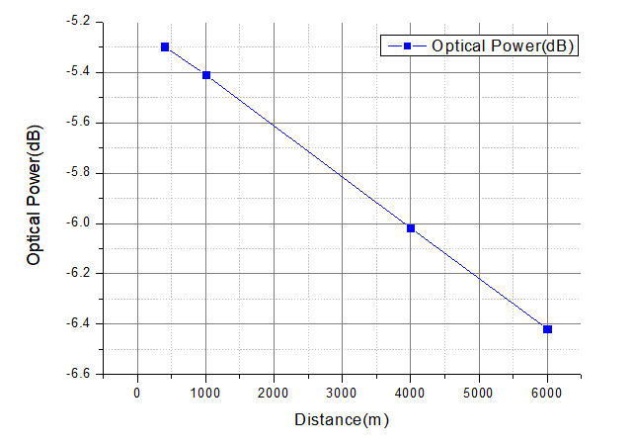Figure 4 Graph for a 2 dB loss at the various distances

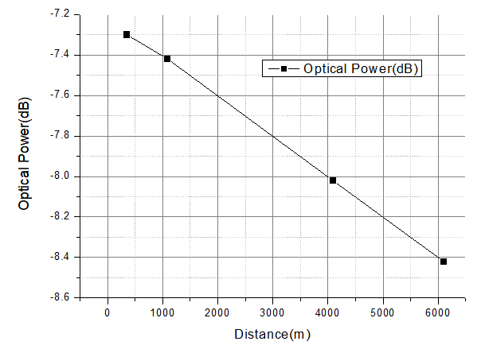

Figure 5 Graph for a 4 dB loss at the various distances

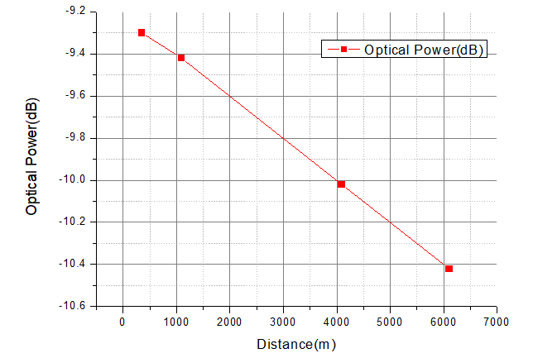

Figure 6 Graph for a 6 dB loss at the various distances

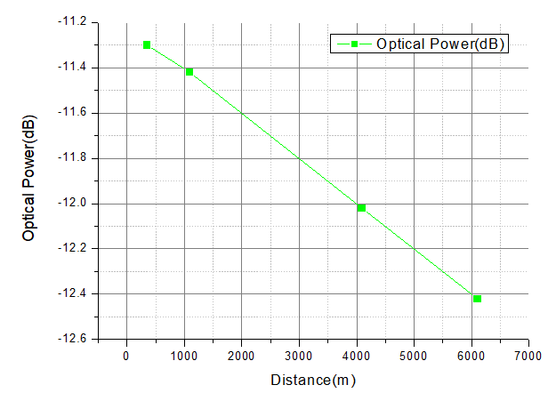

Figure 7 Graph for a 8 dB loss at the various distances

* 1. **Testing**

The wavelength under which the system was tested was set to 1550 nm. The pulse width was selected to be 10 ns and 50 ns to ensure better resolution of the OTDR and distance tradeoffs on every trace. The direction (length) of the transmission was set from end to end (A to B). The refractive index of the core of the fiber was 1.467 with a backscatter coefficient of -79.40 dB. Different dynamic ranges were tested based on our OTDR design and settings. The launch conditions were critically observed as poor launch conditions, which will result in low injection levels, hence the reduction of the dynamic range, and therefore the accuracy of the measurements. In assessing the cabling quality of the link, the following parameters were considered: distance to events, attenuation, optical return loss (ORL), event loss, and event reflection. These parameters were used to determine how efficiently or robust the link was built. From these parameters, we compare the link to an ideal installation. After the system was set up, we shot a trace across. The trace analysis from the start to the end was projected onto the OTDR analysis machine. The events that happened along the fiber length was be analyzed. At the end of the system, the high reflective peak drops down into noise.

**Practical Results**

**Analysis of the system at a distance of 336.23 meters with three events**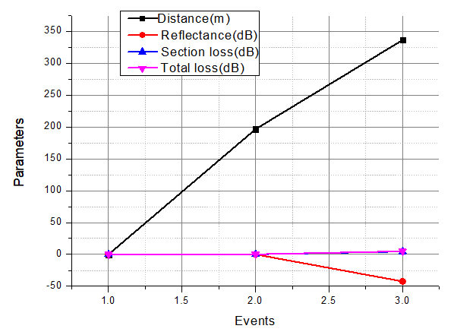

It can be seen from the graphical representation that at every event, the section loss and total loss where very close to each other. This is because we adhered to the standards of fiber optic cable testing and had our losses at a low which signifies that the integrity of the fiber link was good. We also see that there is low reflectance at the third event, signaling that the cable has no faults.

**Analysis of the system at a distance of 1128.71 meters with three events**

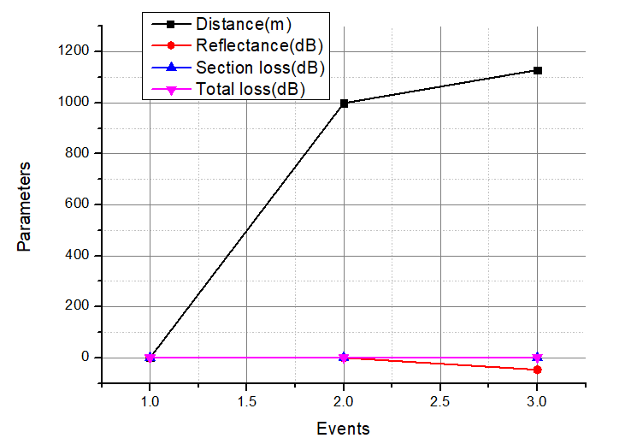

From the graphical representation above, at every event, the section loss and total loss where very close to each other which was similar to the first representation. We also see that there but a higher reflectance at event four which indicates there is a break or a fault at that point.

**Analysis of the system at a distance of 6094.02 meters with eight events**

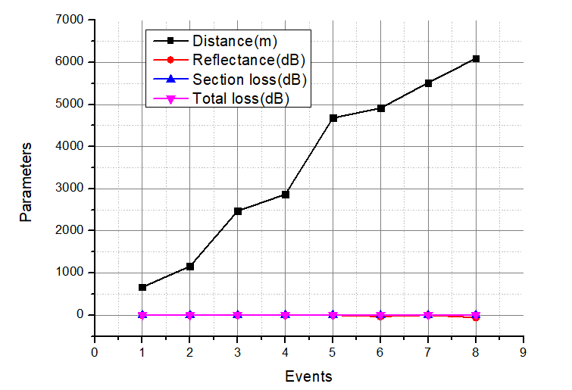

From the graphical representation above, at every event, the section loss and total loss where very close to each other which was similar to previous representations. We also see that there is low reflectance from event one to event five. At event 6, there was a higher reflectance at which indicates there is a break or a fault or even a bend at that point as well as the last event.

**Discussion of Results and Analysis**

From the results, the system developed is able to troubleshoot and detect fault in the optical fiber cable. The system was able to find faults and abnormalities based on the parameters that were set. It can also be seen from the results that we were able to keep the losses of both the events and the overall total losses at a minimum hence, showing the integrity of the cable.

**Performance Evaluation and Limitation of System.**

Existing systems provide a way for fault detection in long haul fiber transmission making it more accurate with the right parameters and the right tools. The table shows the performance of the system.

|  |  |  |  |
| --- | --- | --- | --- |
| Distance (meters) | Pulse  width (nanoseconds) | Time (milliseconds) | Average Loss (dB) |
| Up to 300 | 10 | 5 | 1.94 |
| Between 4000 and 6000 | 50 | 15 | 1.90 |
| From 6000 upwards | 50 | 15 | 1.91 |

*Table 8 Performance of System*

## Limitations

It is quite difficult to find all of the defects in eccentric consecutive faults. The fundamental issue here is that a single flaw causes an optical signal to escape, making it impossible to detect a fault at a distance. As a result, the first defect must be corrected before the next fault can be identified and corrected. Also, more labor charges are incurred, and therefore becomes more expensive for testing.

1. **Conclusion and Recommendation**

The objective of the project was to build a system that detects faults in long haul fiber transmission using Optical Time Domain Reflectometer. Although the necessary components were assembled together in order to detect faults, we only did lab tests and a few on-site tests which was used for graphs, final comparisons, and results since we did not get access to proposed data sources due to a few setbacks. For that, we had to use the data that was obtained for testing the system

* 1. **Recommendations**

Although the system developed provides the intended purpose, there are still recommendations that when considered, will enhance the performance of the system. We recommend that an automated system can be added where an alert can be sent as an SMS to owners of the fiber link due to the continuous monitoring of the fiber link.

* 1. **Observations**

It is observed that fiber optic cables are sensitive and have a high tendency to break so the must be treated with caution. Also, these cables are tiny and hazardous so precautions must be taken when splicing as well as when handling them as it can find its way into the body without your knowledge. Also, it was observed that without the use of OTDR machines, testing the integrity of the cable can be difficult and stressful as well.

**References**

[1] S. Bork, “What Is Optical Fiber Technology, and How Does It Work?” NAI Group, 20-Sep-2019. [Online]. Available: https://www.nai-group.com/optical-fiber-technology-how-it-works/. [Accessed: 04-Aug-2021].

[2] V. Kumar, D. Rajouria “Fault Detection Technique by using OTDR: Limitations and drawbacks on practical approach of measurement,” ResearchGate, Jun-2012. Available: https://www.researchgate.net/publication/317055368_Fault_Detection_Technique_by_using_OTDR_Limitations_and_drawbacks_on_practical_approach_of_measurement.

[3] J. Hayes, *Understanding OTDRs, by Fotec, the fiber optic test equipment company*. [Online]. Available: http://hannah2.be/optische_communicatie/OTDR/index.htm. [Accessed: 30-Jan-2021].

[4] A. Singh, S. Hegiste, and A. Mukri, Department of Electronics & Telecommunications, KALSEKAR Technical Campus, Panvel, Navi Mumbai, Maharashtra, rep., n.d..

[5] J. Brendel, "High-Resolution Photon-Counting OTDR for PON Testing and Monitoring," *OFC/NFOEC 2008 - 2008 Conference on Optical Fiber Communication/National Fiber Optic Engineers Conference*, 2008, pp. 1-5, doi: 10.1109/OFC.2008.4528296.

[6] L. Y. Herrera, F. Calliari, J. D. Garcia, G. C. Amaral and J. P. von der Weid, "High resolution automatic fault detection in a fiber optic link via photon counting OTDR," *2016 Optical Fiber Communications Conference and Exhibition (OFC)*, 2016, pp. 1-3.

[7] A. Nakamura, K. Okamoto, Y. Koshikiya and T. Manabe, "Potential Fault Detection in Optical Cables Using OTDR Operating in Two-Modes," 2019 24th OptoElectronics and Communications Conference (OECC) and 2019 International Conference on Photonics in Switching and Computing (PSC), 2019, pp. 1-3, doi: 10.23919/PS.2019.8817759.

[8] M. Ohashi, H. Kubota and Y. Miyoshi, "OTDR techniques for measuring transmission characteristics of space-division multiplexing fibers," 2020 Opto-Electronics and Communications Conference (OECC), 2020, pp. 1-3, doi: 10.1109/OECC48412.2020.9273723.

[9] M. El-Sayed, P. J. Ibrahim and F. Gunzer, "Investigation of the precision regarding fiber fault location with a commercial Optical Time Domain Reflectometer," 7th International Symposium on High-capacity Optical Networks and Enabling Technologies, 2010, pp. 237-241, doi: 10.1109/HONET.2010.5715781.

[10] “OTDR - Optical Time Domain Reflectometer,” Fluke Networks, 16-Feb-2021. Available: <https://www.flukenetworks.com/expertise/learn-about/otdr>.

[11] “OTDR basic principles - TARLUZ - fiber OPTIC SUPPLIERS,” *TARLUZ*, 24-Feb-2018. [Online]. Available: <http://www.tarluz.com/test-equipment/otdr-basic-principles/#:~:text=An%20OTDR%20sends%20short%20pulses,and%20analyzes%20the%20backscattered%20signals>.

[12] “Non-return-to-zero,” *Wikipedia*, 04-Sep-2021. [Online]. Available: <https://en.wikipedia.org/wiki/Non-return-to-zero>.

[13] “Mach–Zehnder modulator,” *COMSOL*. [Online]. Available: <https://www.comsol.co.in/model/mach-8211-zehnder-modulator-15061>.

[14] “Continuous wave,” *Wikipedia*, 11-Aug-2020. [Online]. Available: <https://en.wikipedia.org/wiki/Continuous_wave>.

[15] “TGxA series Function Generators: Prbs (pseudo-random bit Stream) generation up TO 50MBITS/S,” *AIM*. [Online]. Available: <https://www.aimtti.com/go/tgxa/index.php?p=prbs>.

[16] “Corporate profile,” *OTDR (Optical Time-Domain Reflectometer) - Resources - FTTH Products and Solutions-3C-LINK Technology*. [Online]. Available: <http://www.fiber.asia/index.php?m=content&c=index&a=show&catid=160&id=21>.

[17] A. Yablon, *Optical fiber fusion splicing*. Berlin: Springer, 2010.

[18] “Optical fiber,” *Wikipedia*, 09-Sep-2021. [Online]. Available: <https://en.wikipedia.org/wiki/Optical_fiber>.

[19] Editor, “Single-mode fiber-optic cabling,” *Network Encyclopedia*, 16-Aug-2021. [Online]. Available: https://networkencyclopedia.com/single-mode-fiber-optic-cabling/.

[20] “Stripping (fiber),” *Wikipedia*, 22-Mar-2014. [Online]. Available: https://en.wikipedia.org/wiki/Stripping_(fiber). [Accessed: 24-Sep-2021].

[21] “OptiSystem,” *Optical communication system design software - Third-Party Products & Services - MATLAB & Simulink*. [Online]. Available: https://www.mathworks.com/products/connections/product_detail/optisystem.html